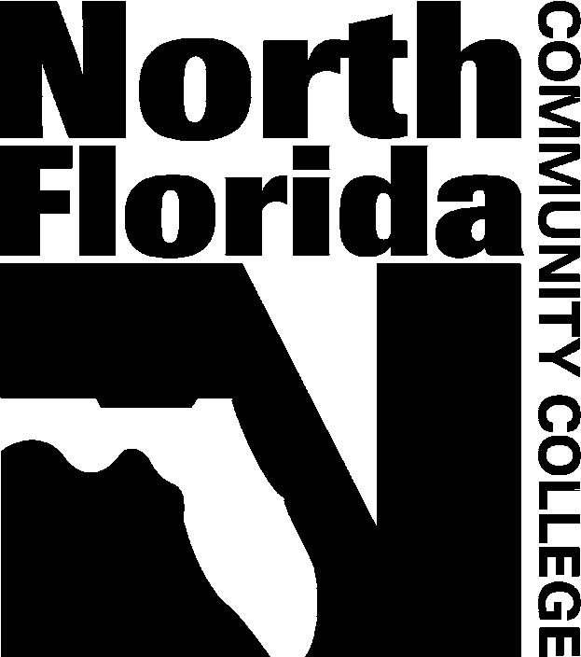
Release of Information

I, , hereby permit North Florida Community College to release the following information from my educational records (check all that apply):

______ Registration PIN number ______ Class Schedule for Current Term
______ Gender ______ Registration History
______ Race/Ethnicity ______ Academic Standing
______ Payment Information/History ______ Financial Aid Information
______ Grades ______ Veterans’ Information
______ Cumulative Credit Hours ______ Other (specify):

The above information may be released by phone, in-person or in writing to the following individuals, once s/he has confirmed my NFCC identification number and date of birth.

I understand that the above information is considered private information under the federal FERPA (Family Educational Rights and Privacy Act) guidelines. By completing and signing this form, I realize that this information will be released to the party (ies) indicated and that this Release will remain in effect until I notify NFCC in writing that I no longer require it. This release does NOT authorize others to drop classes or request transcripts on my behalf without my signature.

Student Name (printed) NFCC ID Number

Student Signature Date

Student E-mail Address Student Phone Number

This form must be submitted in person, with picture identification, to Enrollment Services.

For Office Use: Date Received:__________ Received By: __________

